**Cryptography and Network Security Lab**

**Name: Rushikesh R. Ware**

**PRN: 2020BTECS00012**

**Batch: B2**

**DATA ENCRYPTION STANDARD ALGORITHM**

**Aim:**

To encrypt and decrypt the plain text using DES.

**Theory:**

* The Data Encryption Standard (DES) is a symmetric key block cipher published by National Institute of Standard and Technology (NIST)
* DES is an implementation of a Feistel Cipher. It uses 16 round Feistel structure.
* DES is a block cipher and encrypts data in blocks of size of 64 bits each
* 64 bits of plain text go as the input to DES, which produces 64 bits of ciphertext.
* Though, key length is 64-bit, DES has an effective key length of 56 bits, since 8 of the 64 bits of the key are not used by the encryption algorithm

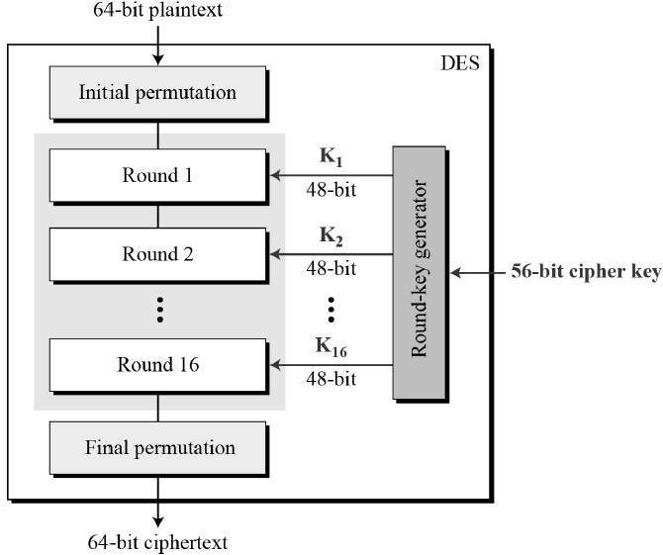

* Since DES is based on the Feistel Cipher, all that is required to specify DES is
* Round function
* Key schedule
* Any additional processing − Initial and final permutation

**Code:**

#include <bits/stdc++.h>

using namespace std;

string hex2bin(string s)

{

    unordered_map<char, string> mp;

    mp['0'] = "0000";

    mp['1'] = "0001";

    mp['2'] = "0010";

    mp['3'] = "0011";

    mp['4'] = "0100";

    mp['5'] = "0101";

    mp['6'] = "0110";

    mp['7'] = "0111";

    mp['8'] = "1000";

    mp['9'] = "1001";

    mp['A'] = "1010";

    mp['B'] = "1011";

    mp['C'] = "1100";

    mp['D'] = "1101";

    mp['E'] = "1110";

    mp['F'] = "1111";

    string bin = "";

    for (int i = 0; i < s.size(); i++)

    {

        bin += mp[s[i]];

    }

    return bin;

}

string bin2hex(string s)

{

    unordered_map<string, string> mp;

    mp["0000"] = "0";

    mp["0001"] = "1";

    mp["0010"] = "2";

    mp["0011"] = "3";

    mp["0100"] = "4";

    mp["0101"] = "5";

    mp["0110"] = "6";

    mp["0111"] = "7";

    mp["1000"] = "8";

    mp["1001"] = "9";

    mp["1010"] = "A";

    mp["1011"] = "B";

    mp["1100"] = "C";

    mp["1101"] = "D";

    mp["1110"] = "E";

    mp["1111"] = "F";

    string hex = "";

    for (int i = 0; i < s.length(); i += 4)

    {

        string ch = "";

        ch += s[i];

        ch += s[i + 1];

        ch += s[i + 2];

        ch += s[i + 3];

        hex += mp[ch];

    }

    return hex;

}

string permute(string k, int *arr, int n)

{

    string per = "";

    for (int i = 0; i < n; i++)

    {

        per += k[arr[i] - 1];

    }

    return per;

}

string shift_left(string k, int shifts)

{

    string s = "";

    for (int i = 0; i < shifts; i++)

    {

        for (int j = 1; j < 28; j++)

        {

            s += k[j];

        }

        s += k[0];

        k = s;

        s = "";

    }

    return k;

}

string xor_(string a, string b)

{

    string ans = "";

    for (int i = 0; i < a.size(); i++)

    {

        if (a[i] == b[i])

        {

            ans += "0";

        }

        else

        {

            ans += "1";

        }

    }

    return ans;

}

string encrypt(string pt, vector<string> rkb,

               vector<string> rk)

{

    pt = hex2bin(pt);

    int initial_perm[64] = {58, 50, 42, 34, 26, 18, 10, 2, 60, 52, 44,

                            36, 28, 20, 12, 4, 62, 54, 46, 38, 30, 22,

                            14, 6, 64, 56, 48, 40, 32, 24, 16, 8, 57,

                            49, 41, 33, 25, 17, 9, 1, 59, 51, 43, 35,

                            27, 19, 11, 3, 61, 53, 45, 37, 29, 21, 13,

                            5, 63, 55, 47, 39, 31, 23, 15, 7};

    pt = permute(pt, initial_perm, 64);

    cout << "After initial permutation: " << bin2hex(pt)

         << endl;

    string left = pt.substr(0, 32);

    string right = pt.substr(32, 32);

    cout << "After splitting: L0=" << bin2hex(left)

         << " R0=" << bin2hex(right) << endl;

    int exp_d[48] = {32, 1, 2, 3, 4, 5, 4, 5, 6, 7, 8, 9,

                     8, 9, 10, 11, 12, 13, 12, 13, 14, 15, 16, 17,

                     16, 17, 18, 19, 20, 21, 20, 21, 22, 23, 24, 25,

                     24, 25, 26, 27, 28, 29, 28, 29, 30, 31, 32, 1};

    int s[8][4][16] = {

        {14, 4, 13, 1, 2, 15, 11, 8, 3, 10, 6, 12, 5,

         9, 0, 7, 0, 15, 7, 4, 14, 2, 13, 1, 10, 6,

         12, 11, 9, 5, 3, 8, 4, 1, 14, 8, 13, 6, 2,

         11, 15, 12, 9, 7, 3, 10, 5, 0, 15, 12, 8, 2,

         4, 9, 1, 7, 5, 11, 3, 14, 10, 0, 6, 13},

        {15, 1, 8, 14, 6, 11, 3, 4, 9, 7, 2, 13, 12,

         0, 5, 10, 3, 13, 4, 7, 15, 2, 8, 14, 12, 0,

         1, 10, 6, 9, 11, 5, 0, 14, 7, 11, 10, 4, 13,

         1, 5, 8, 12, 6, 9, 3, 2, 15, 13, 8, 10, 1,

         3, 15, 4, 2, 11, 6, 7, 12, 0, 5, 14, 9},

        {10, 0, 9, 14, 6, 3, 15, 5, 1, 13, 12,

         7, 11, 4, 2, 8, 13, 7, 0, 9, 3, 4,

         6, 10, 2, 8, 5, 14, 12, 11, 15, 1, 13,

         6, 4, 9, 8, 15, 3, 0, 11, 1, 2, 12,

         5, 10, 14, 7, 1, 10, 13, 0, 6, 9, 8,

         7, 4, 15, 14, 3, 11, 5, 2, 12},

        {7, 13, 14, 3, 0, 6, 9, 10, 1, 2, 8, 5, 11,

         12, 4, 15, 13, 8, 11, 5, 6, 15, 0, 3, 4, 7,

         2, 12, 1, 10, 14, 9, 10, 6, 9, 0, 12, 11, 7,

         13, 15, 1, 3, 14, 5, 2, 8, 4, 3, 15, 0, 6,

         10, 1, 13, 8, 9, 4, 5, 11, 12, 7, 2, 14},

        {2, 12, 4, 1, 7, 10, 11, 6, 8, 5, 3, 15, 13,

         0, 14, 9, 14, 11, 2, 12, 4, 7, 13, 1, 5, 0,

         15, 10, 3, 9, 8, 6, 4, 2, 1, 11, 10, 13, 7,

         8, 15, 9, 12, 5, 6, 3, 0, 14, 11, 8, 12, 7,

         1, 14, 2, 13, 6, 15, 0, 9, 10, 4, 5, 3},

        {12, 1, 10, 15, 9, 2, 6, 8, 0, 13, 3, 4, 14,

         7, 5, 11, 10, 15, 4, 2, 7, 12, 9, 5, 6, 1,

         13, 14, 0, 11, 3, 8, 9, 14, 15, 5, 2, 8, 12,

         3, 7, 0, 4, 10, 1, 13, 11, 6, 4, 3, 2, 12,

         9, 5, 15, 10, 11, 14, 1, 7, 6, 0, 8, 13},

        {4, 11, 2, 14, 15, 0, 8, 13, 3, 12, 9, 7, 5,

         10, 6, 1, 13, 0, 11, 7, 4, 9, 1, 10, 14, 3,

         5, 12, 2, 15, 8, 6, 1, 4, 11, 13, 12, 3, 7,

         14, 10, 15, 6, 8, 0, 5, 9, 2, 6, 11, 13, 8,

         1, 4, 10, 7, 9, 5, 0, 15, 14, 2, 3, 12},

        {13, 2, 8, 4, 6, 15, 11, 1, 10, 9, 3, 14, 5,

         0, 12, 7, 1, 15, 13, 8, 10, 3, 7, 4, 12, 5,

         6, 11, 0, 14, 9, 2, 7, 11, 4, 1, 9, 12, 14,

         2, 0, 6, 10, 13, 15, 3, 5, 8, 2, 1, 14, 7,

         4, 10, 8, 13, 15, 12, 9, 0, 3, 5, 6, 11}};

    int per[32] = {16, 7, 20, 21, 29, 12, 28, 17, 1, 15, 23,

                   26, 5, 18, 31, 10, 2, 8, 24, 14, 32, 27,

                   3, 9, 19, 13, 30, 6, 22, 11, 4, 25};

    cout << endl;

    for (int i = 0; i < 16; i++)

    {

        string right_expanded = permute(right, exp_d, 48);

        string x = xor_(rkb[i], right_expanded);

        string op = "";

        for (int i = 0; i < 8; i++)

        {

            int row = 2 * int(x[i * 6] - '0') + int(x[i * 6 + 5] - '0');

            int col = 8 * int(x[i * 6 + 1] - '0') + 4 * int(x[i * 6 + 2] - '0') + 2 * int(x[i * 6 + 3] - '0') + int(x[i * 6 + 4] - '0');

            int val = s[i][row][col];

            op += char(val / 8 + '0');

            val = val % 8;

            op += char(val / 4 + '0');

            val = val % 4;

            op += char(val / 2 + '0');

            val = val % 2;

            op += char(val + '0');

        }

        op = permute(op, per, 32);

        x = xor_(op, left);

        left = x;

        if (i != 15)

        {

            swap(left, right);

        }

        cout << "Round " << i + 1 << " " << bin2hex(left)

             << " " << bin2hex(right) << " " << rk[i]

             << endl;

    }

    string combine = left + right;

    int final_perm[64] = {40, 8, 48, 16, 56, 24, 64, 32, 39, 7, 47,

                          15, 55, 23, 63, 31, 38, 6, 46, 14, 54, 22,

                          62, 30, 37, 5, 45, 13, 53, 21, 61, 29, 36,

                          4, 44, 12, 52, 20, 60, 28, 35, 3, 43, 11,

                          51, 19, 59, 27, 34, 2, 42, 10, 50, 18, 58,

                          26, 33, 1, 41, 9, 49, 17, 57, 25};

    string cipher = bin2hex(permute(combine, final_perm, 64));

    return cipher;

}

int main()

{

    string pt, key;

    cout << "Enter plain text(in hexadecimal): ";

    cin >> pt;

    cout << "Enter key(in hexadecimal): ";

    cin >> key;

    key = hex2bin(key);

    int keyp[56] = {57, 49, 41, 33, 25, 17, 9, 1, 58, 50, 42, 34,

                    26, 18, 10, 2, 59, 51, 43, 35, 27, 19, 11, 3,

                    60, 52, 44, 36, 63, 55, 47, 39, 31, 23, 15, 7,

                    62, 54, 46, 38, 30, 22, 14, 6, 61, 53, 45, 37,

                    29, 21, 13, 5, 28, 20, 12, 4};

    key = permute(key, keyp, 56);

    int shift_table[16] = {1, 1, 2, 2, 2, 2, 2, 2,

                           1, 2, 2, 2, 2, 2, 2, 1};

    int key_comp[48] = {14, 17, 11, 24, 1, 5, 3, 28,

                        15, 6, 21, 10, 23, 19, 12, 4,

                        26, 8, 16, 7, 27, 20, 13, 2,

                        41, 52, 31, 37, 47, 55, 30, 40,

                        51, 45, 33, 48, 44, 49, 39, 56,

                        34, 53, 46, 42, 50, 36, 29, 32};

    string left = key.substr(0, 28);

    string right = key.substr(28, 28);

    vector<string> rkb;

    vector<string> rk;

    for (int i = 0; i < 16; i++)

    {

        left = shift_left(left, shift_table[i]);

        right = shift_left(right, shift_table[i]);

        string combine = left + right;

        string RoundKey = permute(combine, key_comp, 48);

        rkb.push_back(RoundKey);

        rk.push_back(bin2hex(RoundKey));

    }

    cout << "\nEncryption:\n\n";

    string cipher = encrypt(pt, rkb, rk);

    cout << "\nCipher Text: " << cipher << endl;

    cout << "\nDecryption\n\n";

    reverse(rkb.begin(), rkb.end());

    reverse(rk.begin(), rk.end());

    string text = encrypt(cipher, rkb, rk);

    cout << "\nPlain Text: " << text << endl;

}

**Output:**

**Encryption:**

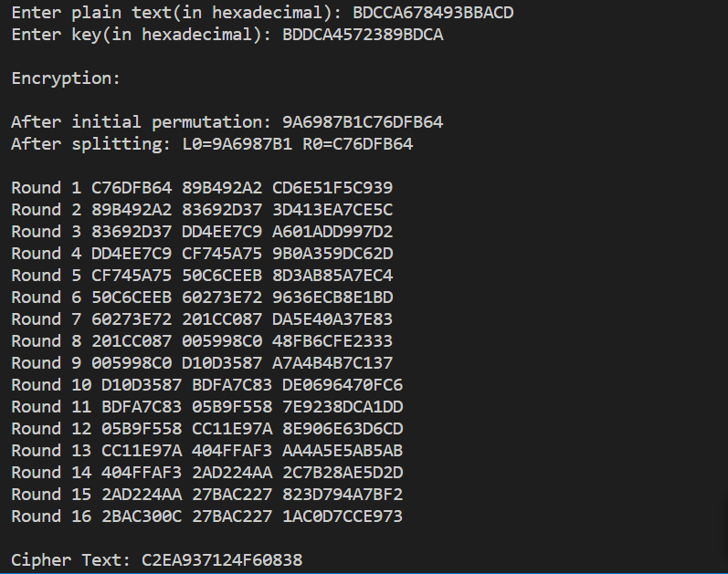

**Decryption:**

